IMDB REVIEWS FOR SENTIMENTAL ANALYSIS

PHASE 2: INNOVATION

TEAM MEMBERS:

1)MAHATHI B (reg no 110321106025)

2)MONISHA A (Reg no.110321106031)

3)RAMANI R (Reg no. 110321106038)

4)RATTHIKA P (Reg no.110321106039)

First by preparing a dataset in emotional analysis, predicting IMDB reviews is a typical problem that has given rise to a number of developments and methodologies. Here are some significant advances and approaches we utilized BERT language model to estimate IMDb reviews and values in our model:

1. Choose pretrained model
2. Tokenization
3. Model architecture
4. Fine tuning process
5. **CHOOSING PRETRAINED MODEL:**

Choosing a pre-trained model in sentiment analysis for IMDb reviews refers to selecting a pre-existing machine learning or deep learning model that has already been trained on a large dataset for a related natural language processing (NLP) task. This pre-trained model serves as the foundation for your sentiment analysis task on IMDb reviews. Here's how it typically works:

1. **Pre-training:** To understand the fundamental language patterns and representations, enormous text corpora (such as Wikipedia, news articles, and books) are used to train NLP models like BERT, GPT-2, and others. These models are made to comprehend relationships, context, and meaning in text.The models can be fine-tuned on a particular sentiment analysis job, like classifying IMDb movie reviews into positive or negative, after pre-training on a general text corpus.
2. **Transfer Learning:** Using pre-trained models has the advantage of bringing a wealth of knowledge about language interpretation, which can dramatically improve the performance of your sentiment analysis work with minimal data and computational resources.
3. **Customization:** Depending on your individual IMDb sentiment analysis needs, you can fine-tune the chosen pre-trained model on IMDb review data to match it to the intricacies and lexicon of movie reviews.

By using a pre-trained model, you can take use of the substantial knowledge already inherent in these models while saving time and effort when compared to building a sentiment analysis model from scratch. Because the model has a strong foundation in comprehending English language, this approach frequently results in more accurate sentiment analysis for IMDb reviews.

**2.TOKENIZATION:**

Tokenization is the process of dividing a review into tokens or words. Tokenization would produce the following: ["This", "movie", "was", "great", "!", "I", "loved", "the", "acting", "and", "the", "plot", "."]

1. **Text Input:** Use a movie review from IMDB as your input. "This movie was fantastic!" for example. "I enjoyed both the acting and the plot."
2. **Cleaning:** You may want to clean the tokens from time to time, eliminating punctuation, converting to lowercase, and handling special characters so that "loved" and "loved!" are treated the same way.
3. **Analysis:** Following tokenization and cleaning, you may undertake sentiment analysis, which entails determining the sentiment of the review (positive, negative, or neutral) based on the words and their context.

Tokenization is an important preprocessing step in natural language processing applications such as sentiment analysis since it enables the algorithm to deal with structured input that can then be fed into machine learning models for sentiment classification.

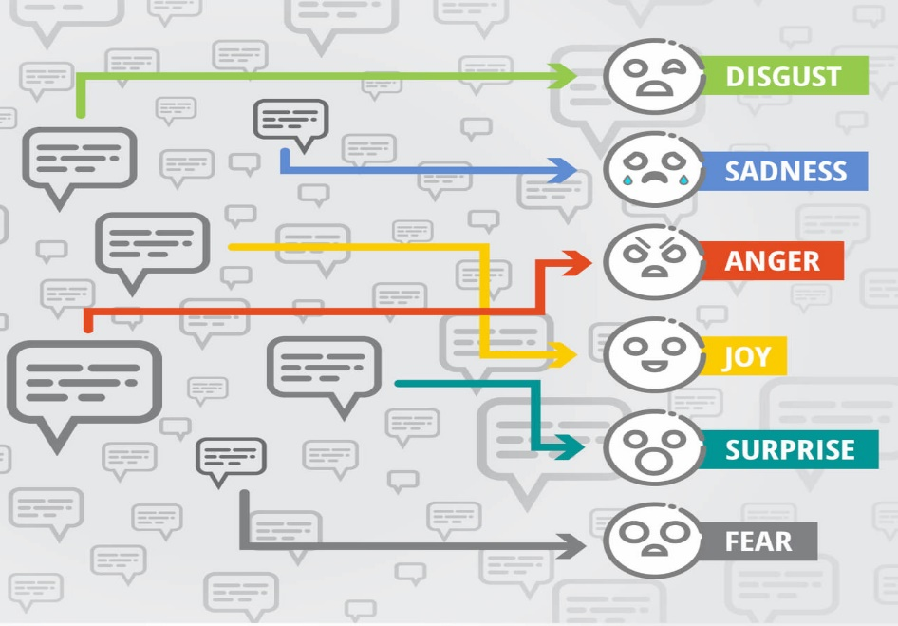

**3.MODEL ARCHITECTURE :**

* **Input Layer:** The input layer represents the text data from IMDb reviews, usually encoded as sequences of words or word embeddings.
* **Word Embeddings:** Pre-trained word embeddings like Word2Vec, GloVe, or fastText are often used to convert words into dense vector representations, capturing semantic relationships.
* **Convolutional Layers:** In CNN-based architectures, convolutional layers are used to detect patterns and features in the word embeddings. These layers slide filters over the text data to identify relevant features.
* **Pooling Layers:** Max-pooling or average-pooling layers are applied to reduce the dimensionality and capture the most important information from the convolutional layers.
* **Fully Connected Layers:** These layers process the extracted features and feed them into a neural network that maps them to a binary sentiment prediction (positive or negative).
* **Output Layer:** The output layer typically consists of a single neuron with a sigmoid activation function, which outputs a probability score between 0 and 1. A threshold (e.g., 0.5) is used to classify the sentiment.
* **Training:** The model is trained on a labeled dataset of IMDb reviews with their corresponding sentiments. The loss function, such as binary cross-entropy, measures the prediction's error, and optimization techniques like gradient descent are used to update the model's weights.

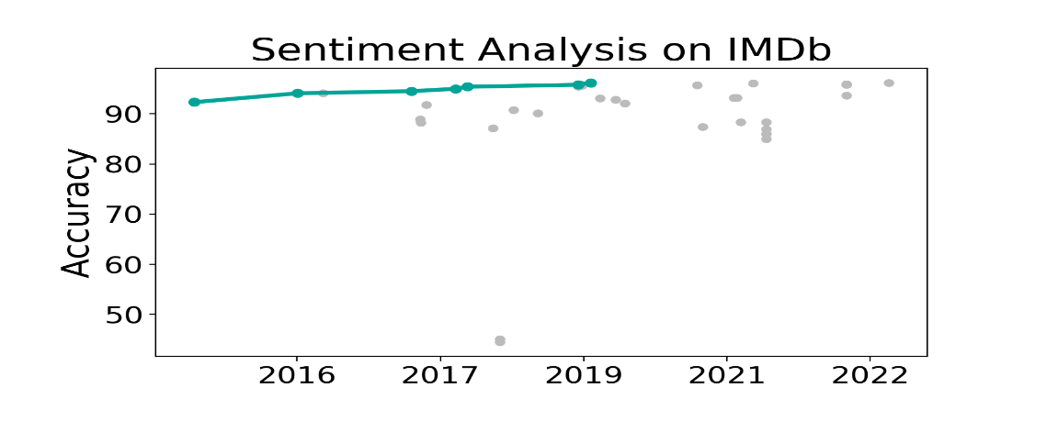

**4.FINE TUNING PROCESS:**

In the context of sentiment analysis for IMDb reviews, fine-tuning often refers to the process of adjusting a pre-trained model to perform better on IMDb movie reviews. Here's a quick rundown of the fine-tuning procedure:

* **Pre-trained Model:**

Begin using a model that has already been trained on a big dataset, such as BERT. From large amounts of text data, these models have learnt a good representation of the language.

* **IMDb Dataset:**

Compile a dataset of IMDb reviews that have been labeled with their feelings (e.g., positive or negative).

* + **Fine-tuning:**

Train the pre-trained model using the IMDb dataset. The model's weights are incrementally changed during this process to make it better at predicting sentiment in movie reviews.

* + **Divide the dataset into two parts:**

Feed the training set reviews into the pre-trained model.Adjust the weights of the model based on the difference between its predictions and the actual sentiments.

To avoid overfitting, keep an eye on performance on the validation set.

After fine-tuning, assess the model's performance on a test set of IMDb reviews that it hasn't seen previously. This indicates how well the model will function in realistic settings.

* + **Deployment:**

Once the model's performance has been validated, it may be used to forecast the sentiment of fresh IMDb reviews.

Remember that fine-tuning must be handled carefully to avoid overfitting, especially when the fine-tuning dataset (IMDb reviews in this case) is significantly smaller than the original dataset on which the model was pre-trained.

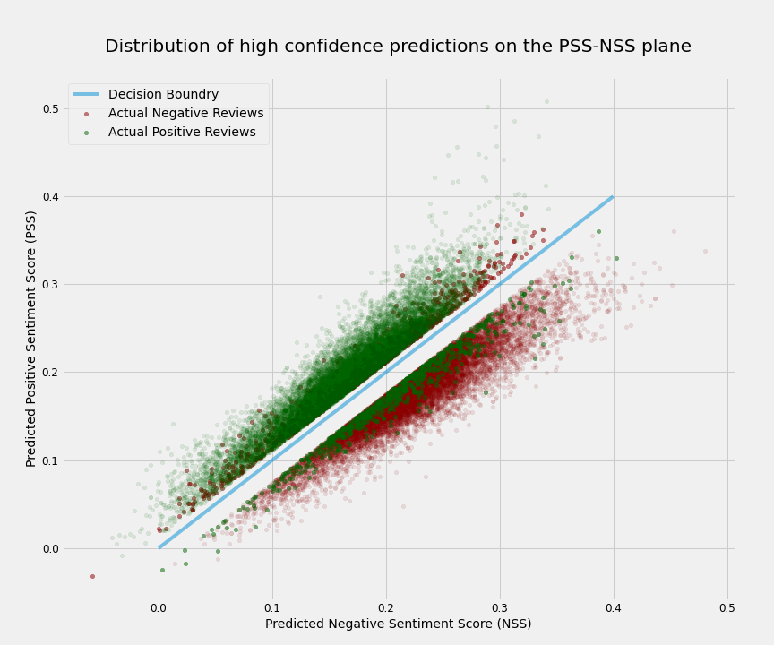

**EVALUATION:**

The process of examining the effectiveness and accuracy of a sentiment analysis model in classifying movie reviews into sentiment categories, such as positive, negative, or neutral, is referred to as evaluation in sentiment analysis for IMDb reviews. It is critical to evaluate a sentiment analysis model in order to discover how effectively it can forecast the sentiment of IMDb reviews. You can examine a sentiment analysis model for IMDb reviews' strengths and weaknesses, make required improvements, and verify that it satisfies the acceptable accuracy and reliability for classifying movie reviews based on sentiment by thoroughly assessing it.

**Some of the innovative features for creating a SENTIMENT ANALYSIS FOR MARKETING in python using sample code:**

Sentiment analysis for marketing can be enhanced with innovative features to gain deeper insights into customer sentiments and preferences. Here are some feature ideas along with sample Python code snippets:

1. **Emotion Analysis:**

- Analyze the emotional tone of the text, such as happiness, anger, or sadness, using pre-trained emotion classifiers.

**CODE**

from transformers import pipeline

emotion_classifier = pipeline("sentiment-analysis")

emotions = emotion_classifier(text)

2. **Emoji Analysis:**

- Identify and analyze emojis in the text to understand the emotional context.

**CODE**

import emoji

emoji_list = [c for c in text if c in emoji.UNICODE_EMOJI]

```

3. **Customer Engagement Metrics:**

- Calculate engagement metrics like the number of likes, shares, and comments on social media posts.

**CODE**

likes = post_data['likes']

shares = post_data['shares']

comments = post_data['comments']

```

4. **Temporal Analysis:**

- Analyze sentiment changes over time, such as hourly, daily, or weekly sentiment trends.

**CODE**

import pandas as pd

df['timestamp'] = pd.to_datetime(df['timestamp'])

df.set_index('timestamp', inplace=True)

daily_sentiment = df.resample('D')['sentiment_score'].mean()

5. **Product/Service Mention Analysis**:

- Detect mentions of specific products or services and analyze sentiment related to them.

**CODE**

product_mentions = [product for product in products if product in text]

6. **Influence Network Analysis:**

- Analyze the network of influencers and their impact on sentiment.

**CODE**

import networkx as nx

G = nx.Graph()

G.add_edges_from(influencer_connections)

degree_centrality = nx.degree_centrality(G)

7. **Customer Demographics:**

- Incorporate customer demographics (e.g., age, gender) and analyze sentiment variations across different groups.

**CODE**

age_group = get_age_group(customer_age)

gender = get_gender(customer_gender)

8. **Competitor Mentions:**

- Detect mentions of competitors and analyze sentiment in comparison to your brand.

**CODE**

competitor_mentions = [comp for comp in competitors if comp in text]

9. **Keyword Association:**

- Identify and analyze the sentiment associated with specific keywords or phrases relevant to your industry.

**CODE**

relevant_keywords = ['keyword1', 'keyword2', 'keyword3']

keyword_sentiment = sum(text.count(keyword) for keyword in relevant_keywords)

10. **Location-Based Sentiment:**

- Analyze sentiment by location to understand regional variations.

**CODE**

user_location = get_user_location(user_ip)

location_sentiment = location_sentiment_model.predict(user_location)

These innovative features can help you gain a more nuanced understanding of customer sentiment and provide actionable insights for marketing strategies. Depending on your specific use case, you may need to combine these features and apply machine learning techniques to extract valuable insights from your data.